DYNAMIC TABLES
On continuation of previous post, Let us see the limitations on setting up the lag time
First delete the records in staging table
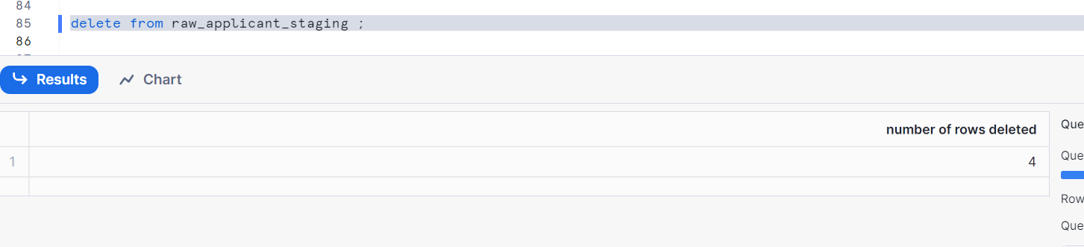
Inserting two rows in staging
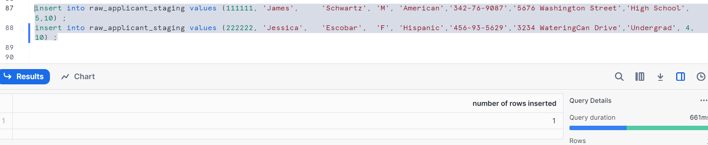
Check the data in both tables
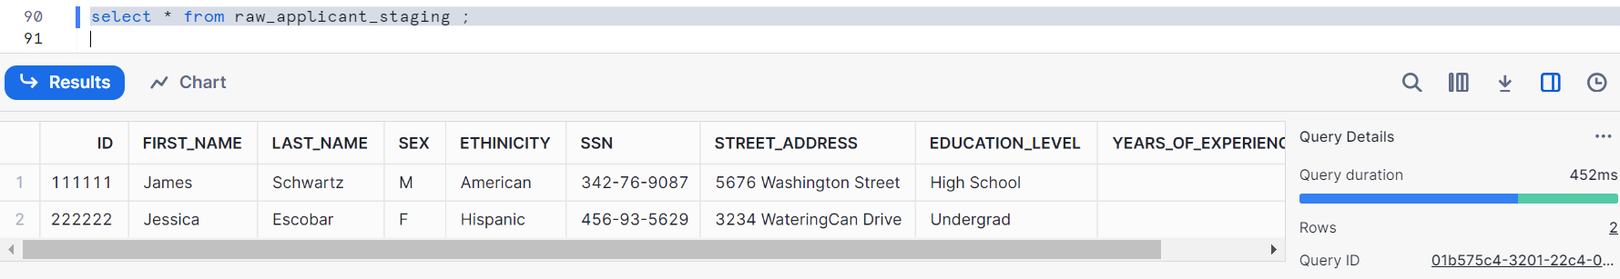
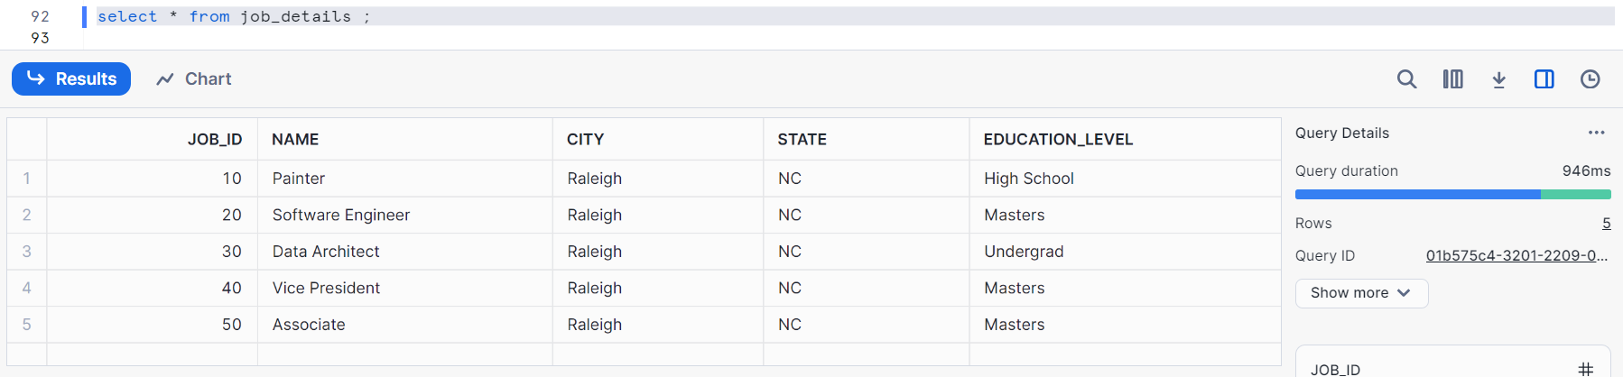

Let’s see the existing Dynamic table graph we have
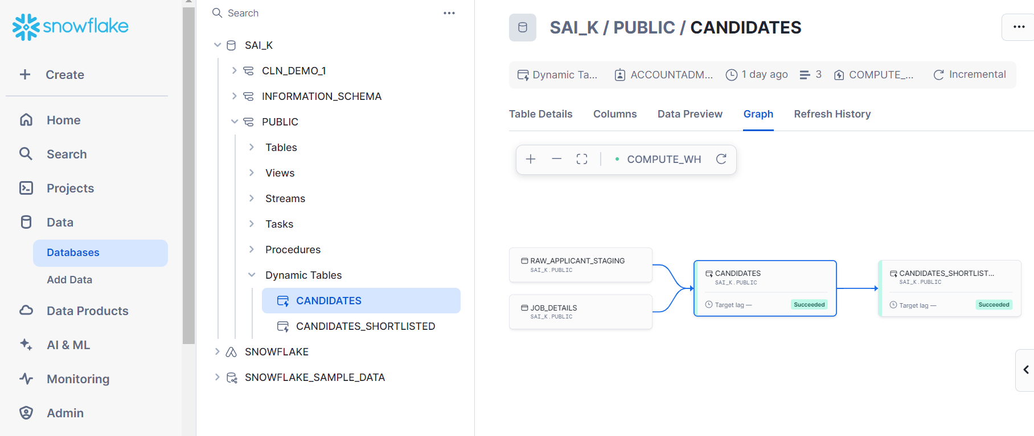
Let’s introduce some error while creating dynamic table
With syntax error as shown
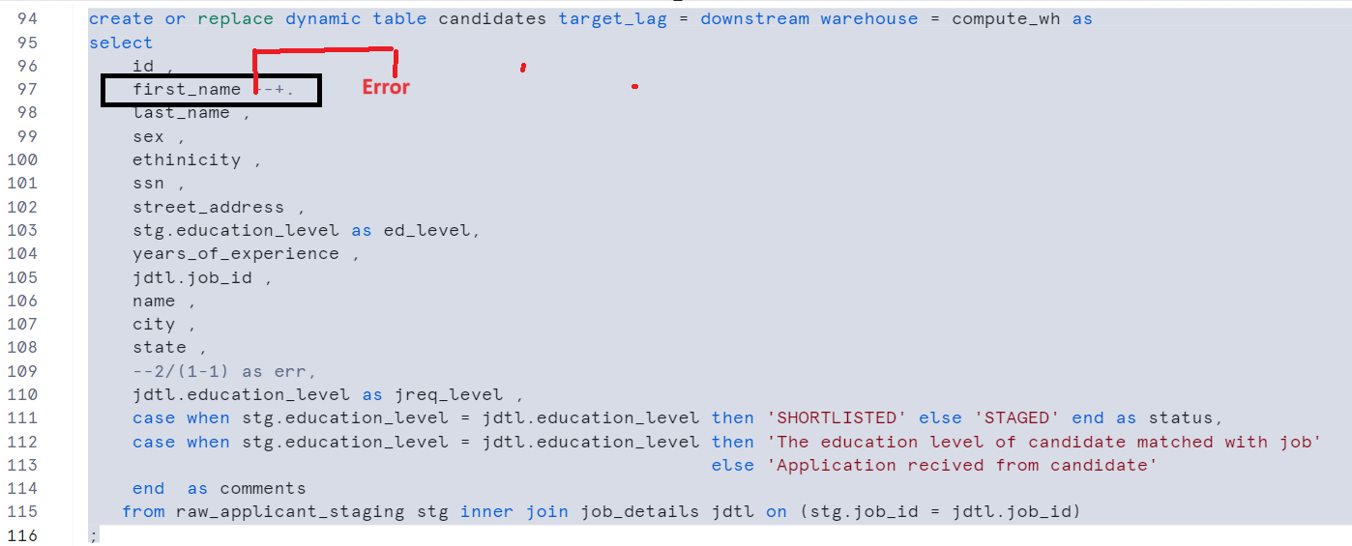
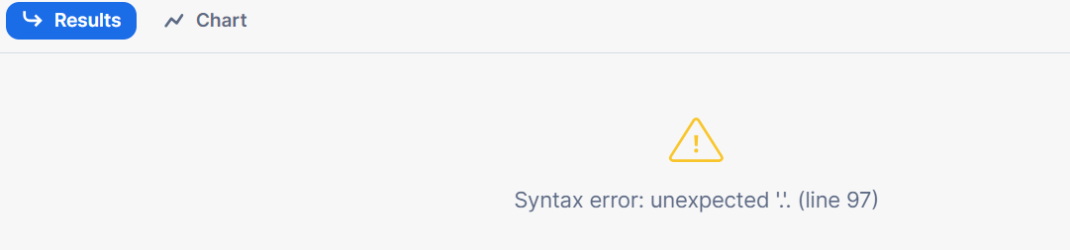

Let’s introduce run time error
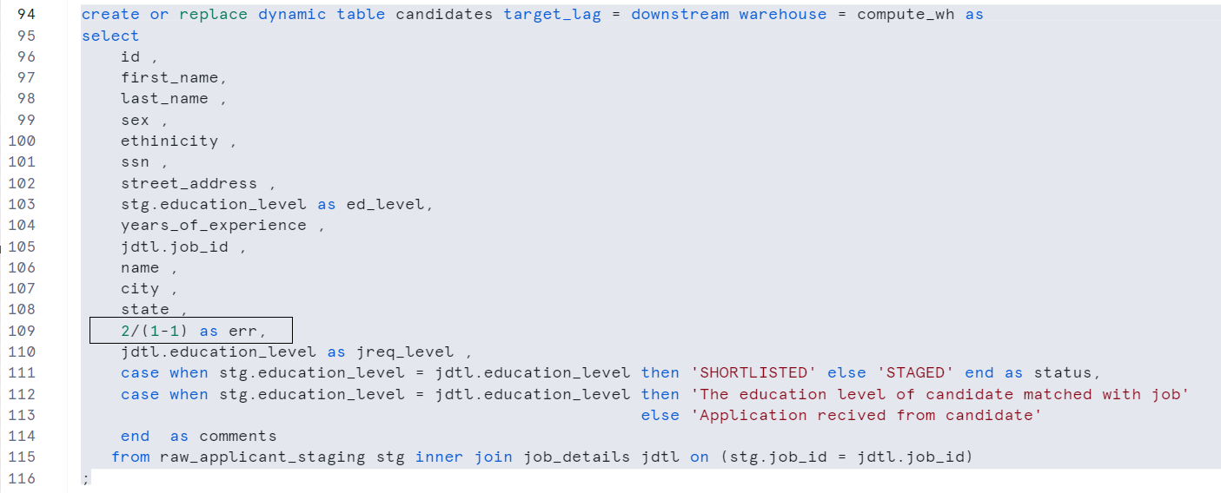
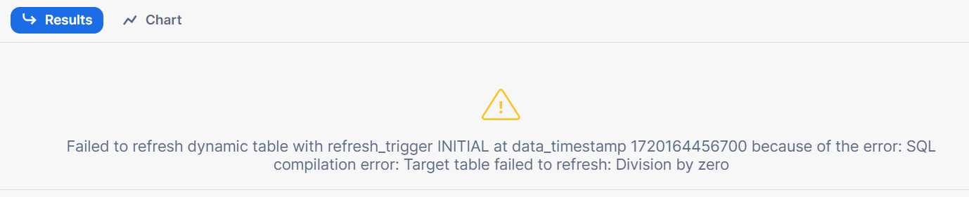
We can’t create dynamic tables if have SQL syntax error or run time error

Let’s remove the error and recreate it
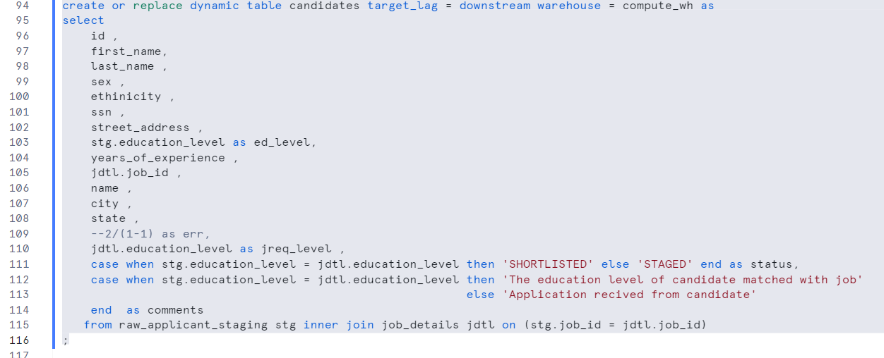
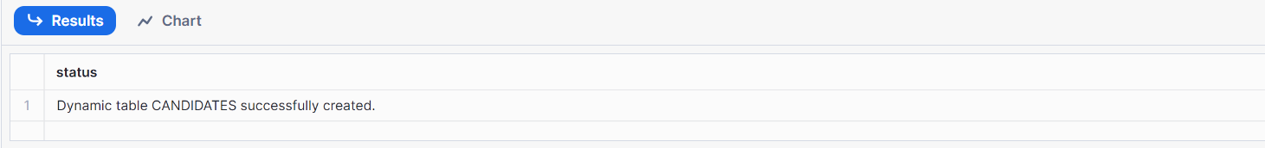
Create another dynamic table on candidates
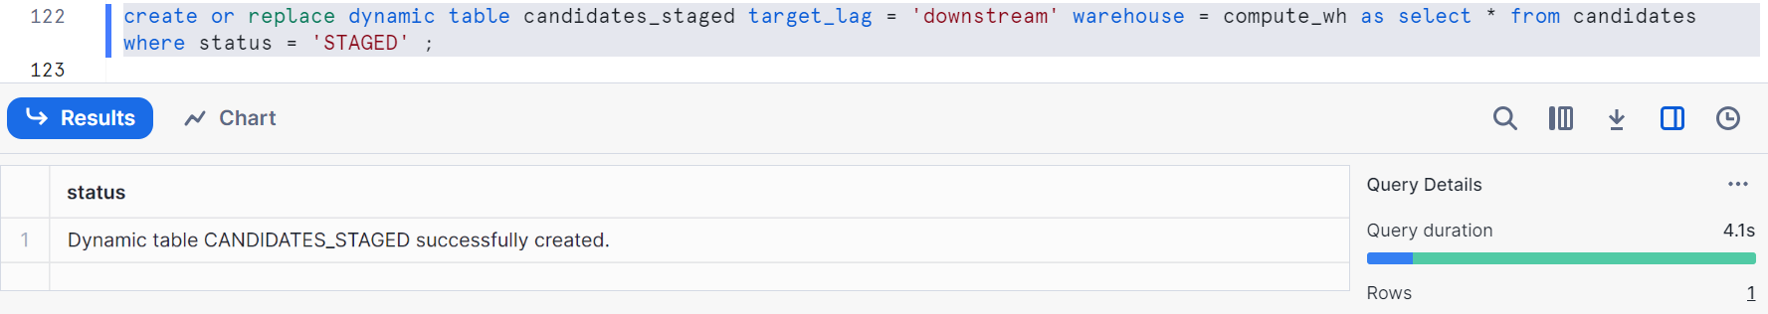
Now check the data
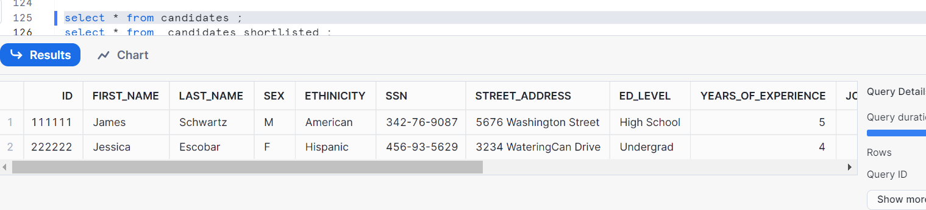
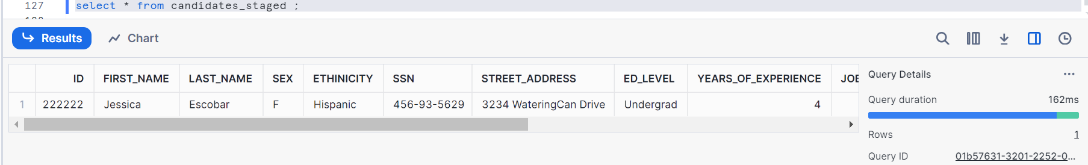
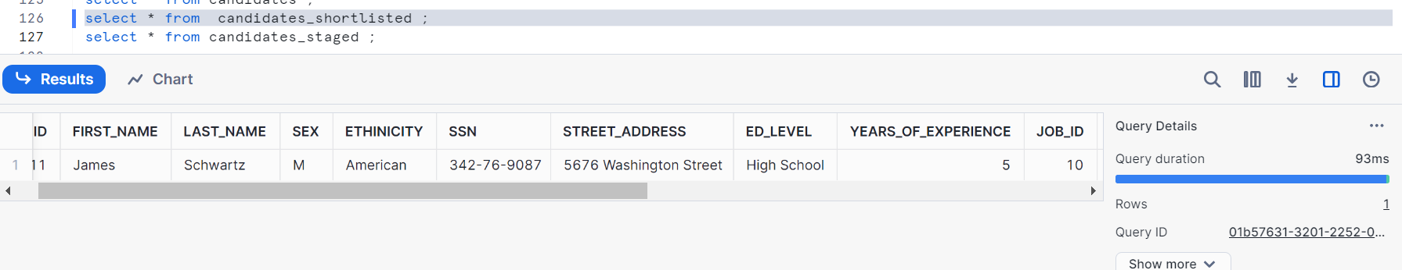
Hence, we had 1 record status as shortlisted and 1 record status as staged

Let’s see the graph (please follow my previous post if you are not aware)
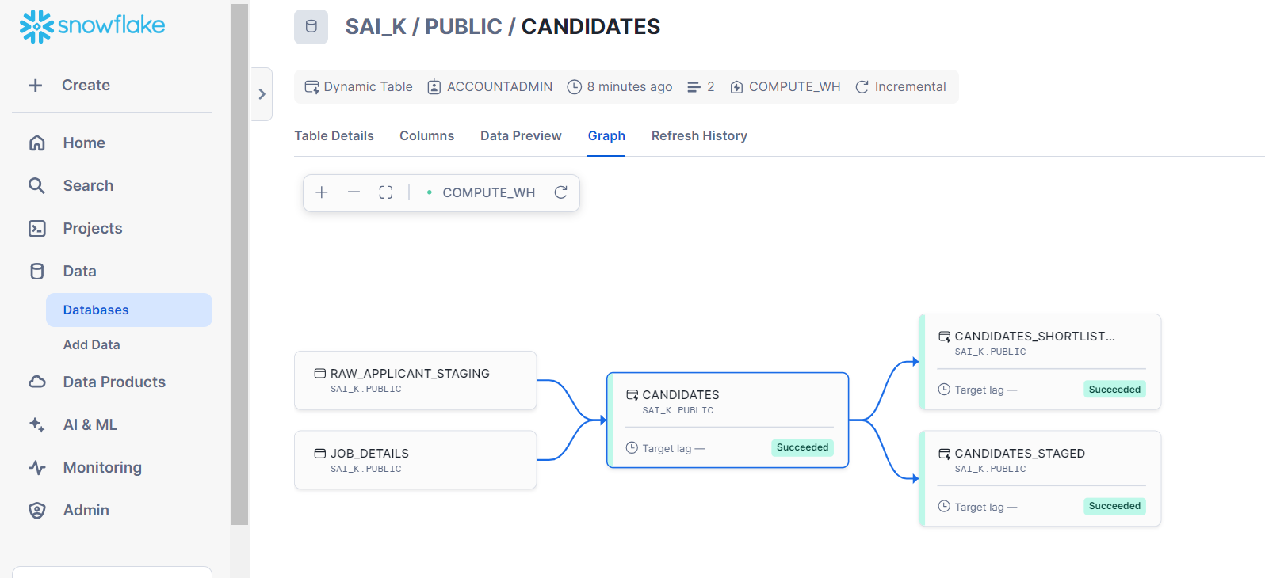
For now, there is no target lag in above graph (you can see above in green color box beside)
Let’s test the lag for dependencies. It gives error. Let us check
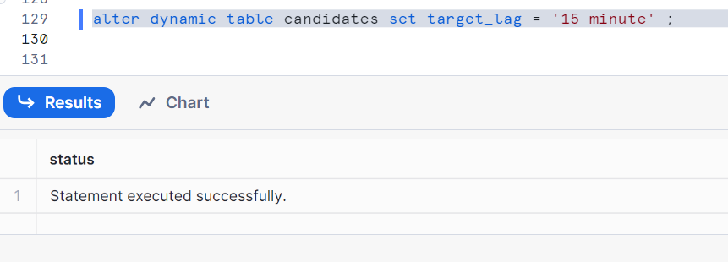
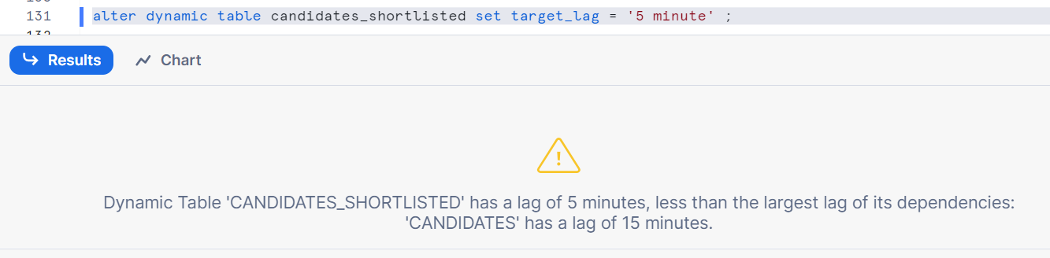
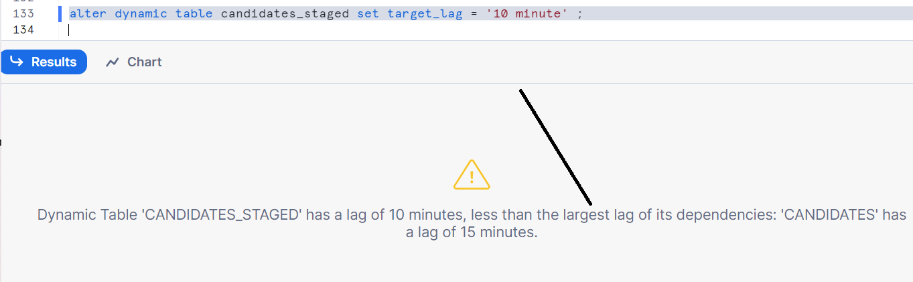
As I had set my target lag to 15 min in candidates, it gets refreshed every 15 min
Now as candidates shortlisted and candidates staged tables comes after candidates, you can’t set up lag time less than candidates lag time

Case1:
Let’s change time for both candidates_shortlisted and candidates_staged greater than candidates lag time
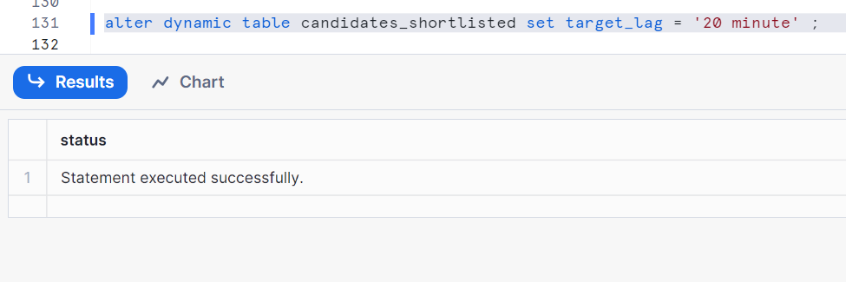
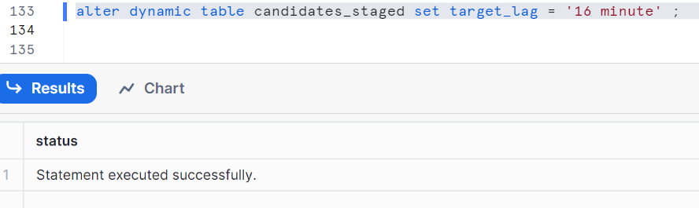

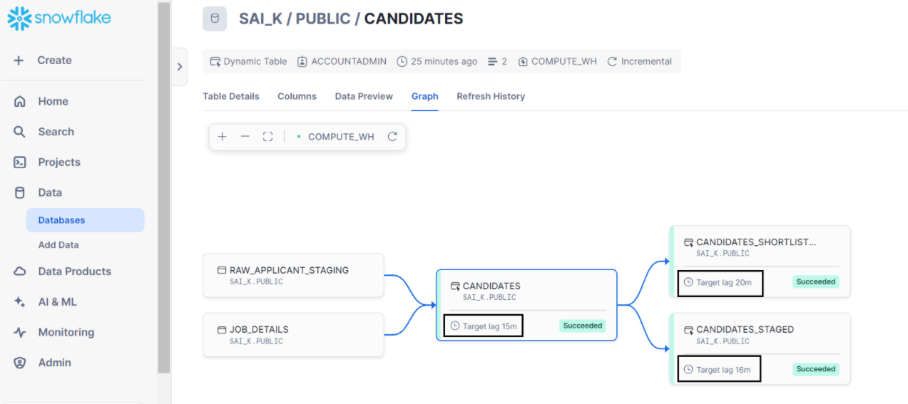

Case2: let’s change candidates lag time to downstream and check
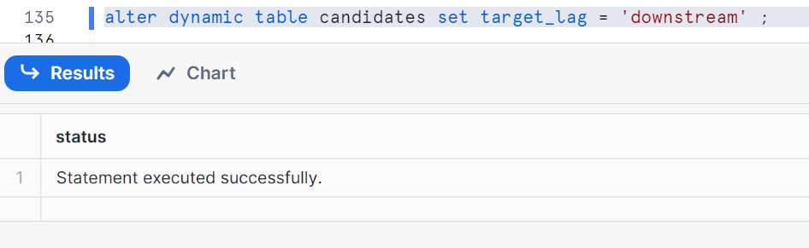
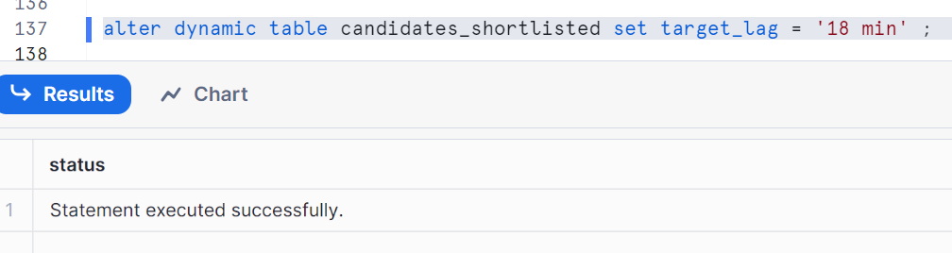
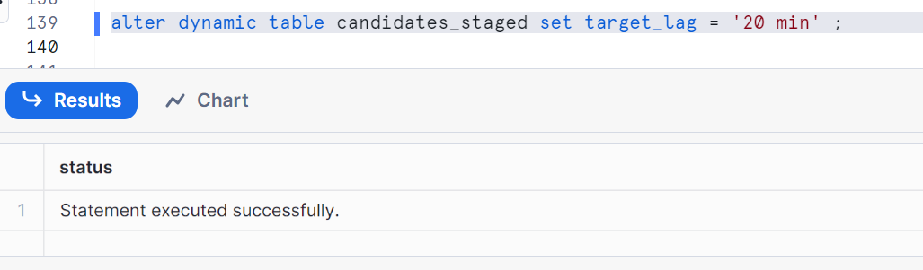
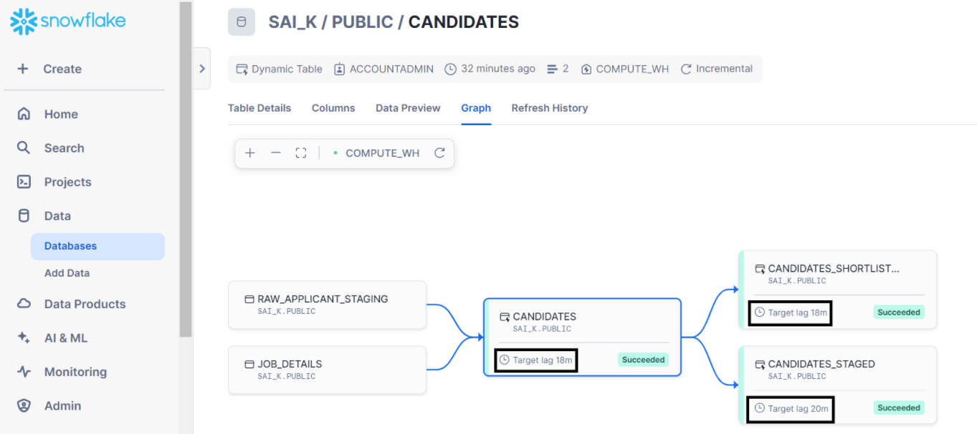
Hence, candidates lag time is taken with minimum number of two dynamic tables lag times
Therefore snowflake manages dependencies like this

Case3:
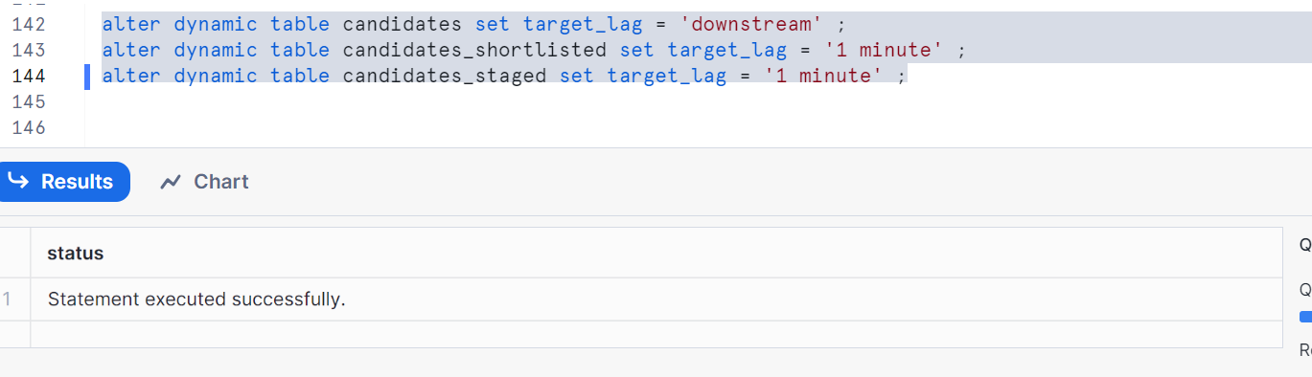
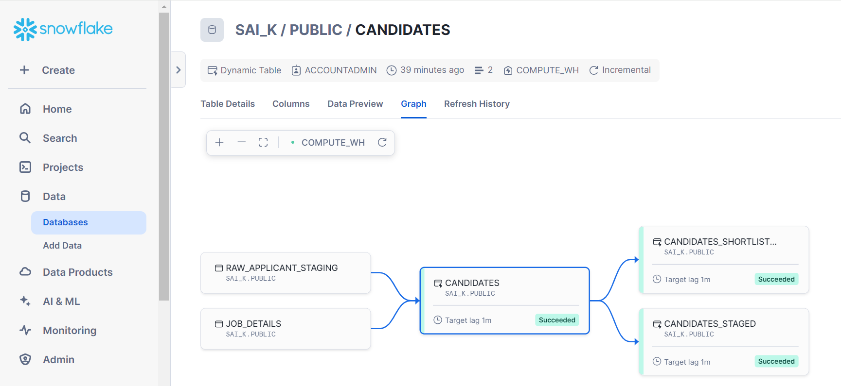

Case4:
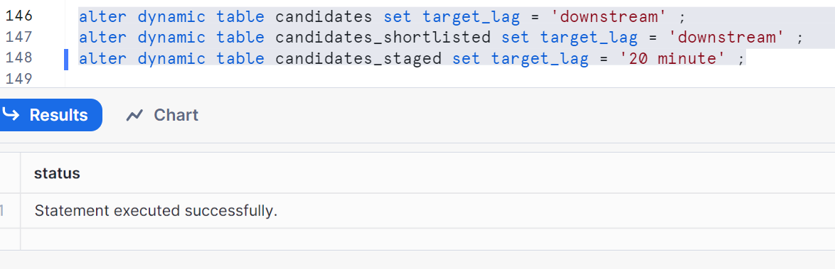
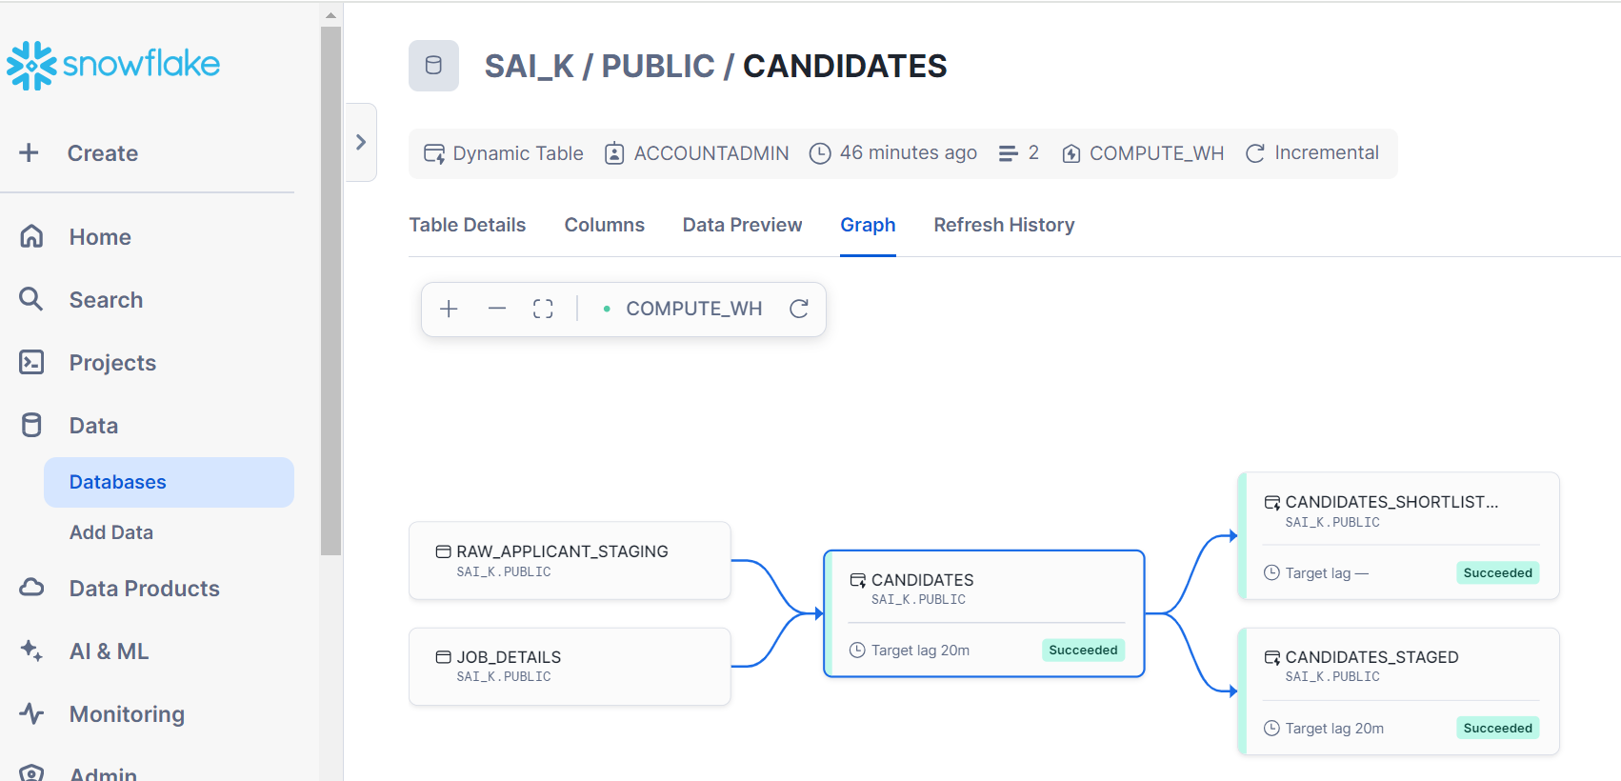
Candidates lag time is minimum of two dynamic tables lag time and no lag time for candidates_shorlisted

Note:
I recommend you to give a small lag time like 1 min, apply with different scenarios by inserting records in candidates table so that it should reflect dynamic table records after lag times

